FEDERATIVE REPUBLIC OF BRAZIL
Ministry of Mines and Energy · Secretariat of Petroleum, Natural Gas and Biofuels

Agro-Thermal Resource Recovery
Intelligence System (ATRIS)

A Proposal for Cluster-Based Implementation in the Brazilian Sugarcane Belt

Submitted for Consideration · April 2026 · Independent Research Study

1. EXECUTIVE SUMMARY

Brazil is the world's second-largest ethanol producer and the global leader in sugarcane-based biofuel. Its 356 operational sugarcane mills and 375 first-generation ethanol plants collectively process more than 600 million tonnes of sugarcane per year, producing 32.5 billion litres of ethanol annually. Yet this industry — the most energy-efficient biofuel system in the world, with an output-to-input energy ratio of 8.3 to 10.2 — is simultaneously generating massive volumes of underutilised byproduct streams that are currently treated as waste management problems rather than resource streams.
For every litre of ethanol produced, approximately 12 litres of vinasse are generated as a liquid byproduct — producing a national total of approximately 390 billion litres per year. Fermentation releases CO2 at near-99% purity, currently vented to atmosphere at zero revenue. Bagasse combustion generates continuous low-grade waste heat that is partially recovered for electricity but substantially lost through exhaust and cooling systems. Process wastewater across the milling, fermentation, and distillation stages contains recoverable water and organic compounds.
This proposal presents the Agro-Thermal Resource Recovery Intelligence System (ATRIS): a cluster-based, distributed resource recovery network designed to transform Brazil's sugarcane industry from a fuel production system into a fully integrated multi-resource biorefinery. ATRIS does not require new feedstock, new industrial sites, or new energy inputs. It captures what is already being generated and currently lost, at the lowest possible incremental cost.

THE PROPOSAL
ATRIS targets deployment across 50 sugarcane clusters in São Paulo, Mato Grosso do Sul, Goiás, Minas Gerais, and Paraná — Brazil's five primary cane-producing states. Each cluster aggregates 3 to 7 mills within a 150 km radius for shared infrastructure. Priority recovery streams in order of ROI: fermentation CO2 capture, waste heat-to-water recovery, vinasse anaerobic digestion (biogas), and concentrated fertilizer extraction. Estimated combined national value of recovered resources: R$ 18 to 28 billion annually at full scale. Zero new feedstock required. Zero new land required. No increase in water or energy input.

32.5B L/yr  Ethanol Production  Brazil 2024 forecast | 390B L/yr  Vinasse Generated  12 L per L ethanol | ~99%  Fermentation CO₂ Purity  Lowest-cost CCS source | 9%  National Electricity  From bagasse cogeneration

2. STRATEGIC CONTEXT: THE UNOPTIMISED BIOREFINERY

Brazil's sugarcane industry is, in engineering terms, a partially optimised multi-resource refinery. The primary product — ethanol — is produced with world-class efficiency. The energy balance of 8.3 to 10.2 (output/input) is the highest of any commercial biofuel. Bagasse cogeneration supplies 9% of Brazil's national electricity, with seasonal value as a dry-season balancing resource for the country's predominantly hydroelectric grid. These achievements are real and significant.
What is not optimised is the treatment of byproduct streams. Brazil generates 390 billion litres of vinasse per year — a volume with pollution potential 100 times that of domestic sewage by BOD concentration — and distributes most of it via open-channel fertigation, a practice that is geographically limited, environmentally problematic at high application rates, and economically inefficient relative to the resource content of the stream. Fermentation CO2, the purest industrial CO2 stream available anywhere in the world, is vented to atmosphere at a market value of $25 to $60 per tonne. Low-grade waste heat from boilers, turbines, and exhaust gases is partially used for electricity but substantially lost. Process wastewater is treated as an environmental liability rather than a water recovery source.
The strategic insight is simple: Brazil's agro-industry is not producing ethanol. It is producing ethanol, water, carbon, energy, and fertiliser — while accounting for and monetising only the first. ATRIS is the system that accounts for the rest.
Alignment with Brazilian National Policy
Policy Framework | ATRIS Contribution
RenovaBio: reduce carbon intensity of biofuels | Fermentation CO2 capture and utilisation directly reduces the CI score of Brazilian sugarcane ethanol from 32.8 to ~10.4 gCO2e/MJ under BECCS from fermentation — unlocking higher RenovaBio credit revenues
National Bioeconomy Strategy (2020) | ATRIS is a direct implementation of the bioeconomy principle: converting biological waste streams into primary economic outputs
Brazil's NDC: 48.4% GHG reduction by 2025, 53.1% by 2030 | CO2 capture, reduced vinasse open-channel distribution, and biogas displacement of fossil energy contribute to sectoral emissions reduction
ProBiogas: national biogas program | ATRIS vinasse anaerobic digestion module scales ProBiogas across the entire sugarcane belt, not individual plants
National Water Resources Policy | Process wastewater recovery and reduced vinasse run-off directly address groundwater contamination risks in the Guarani Aquifer region

3. INPUT STREAM CHARACTERISATION & NATIONAL VOLUMES

The following input streams are generated continuously during Brazil's 200 to 240-day annual harvest and processing season. All volumes are derived from verified production data for Brazil's 375 first-generation ethanol plants.

Stream | Source | National Volume | Current Disposition | Recovery Potential
Bagasse waste heat (low-grade, 80–150°C) | Boiler exhaust, turbine condensate | ~100–150 GW thermal, national; ~657,000 t bagasse/day from autonomous plants | Partially used for cogeneration; exhaust heat largely lost | HIGH — direct MED input for water recovery; ~15–25% currently unutilised
Fermentation CO₂ | Sugarcane juice fermentation tanks | ~34 Mt CO₂/yr (from 32.5B L ethanol at ~1 kg CO₂/L) | Vented to atmosphere at zero value | VERY HIGH — 99% pure; lowest-cost CCS source globally at $25–52/t abated
Vinasse | Ethanol distillation column bottoms | ~390B L/yr (12 L per L ethanol) | Open-channel fertigation; partially stored in lagoons | HIGH — anaerobic digestion to biogas; water recovery after concentration
Process wastewater | Washing, milling, juice processing | ~15–20 L per tonne of cane; ~9–12B L/yr nationally | Effluent treatment; partial reuse | MEDIUM — recoverable after ultrafiltration + UV
Cane trash & straw | Post-harvest residue | ~140–180 kg per tonne of cane dry basis | ~50% burned in field; 50% left on soil | MEDIUM — gasification or additional cogeneration feedstock

4. SYSTEM ARCHITECTURE: THE ATRIS CLUSTER MODEL

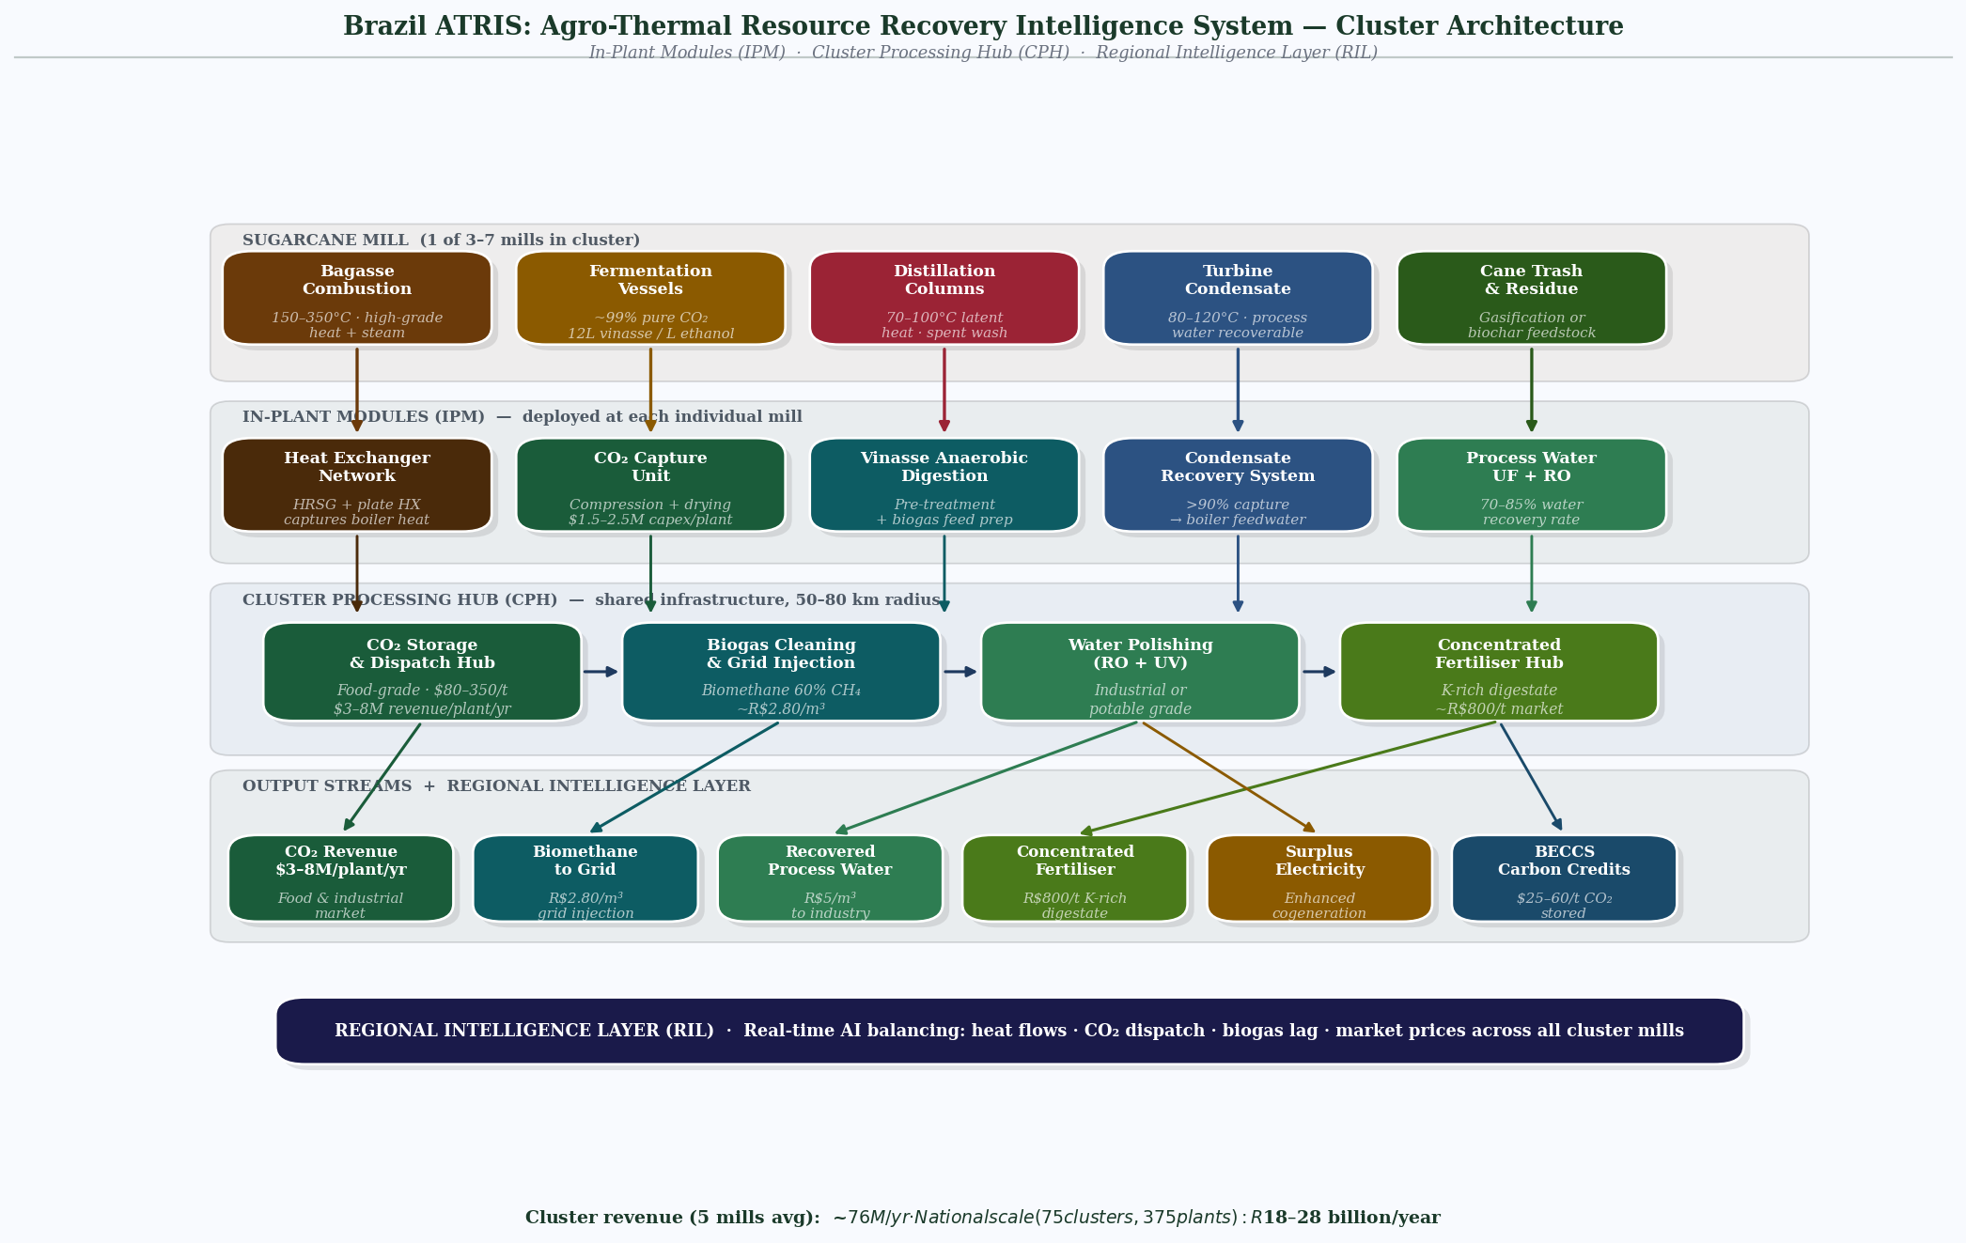
Fig. 1 ATRIS cluster architecture — four-layer flow from sugarcane mill inputs (bagasse combustion, fermentation CO₂, vinasse, condensate) through in-plant modules and cluster processing hub to six revenue streams; regional intelligence layer balances flows across 3–7 mills per cluster
Unlike the Gulf system — where a centralized thermal hub aggregates waste streams from geographically proximate heavy industries — Brazil's sugarcane industry is distributed across a 2,000 km belt. No single plant generates sufficient waste stream volume to justify the capital cost of a full recovery system. The ATRIS solution is cluster-based deployment: regional aggregation of 3 to 7 mills within a 150 km radius, sharing infrastructure for the highest-capex components while implementing in-plant modules for low-capex, high-ROI streams.
4.1 Cluster Architecture
Each ATRIS cluster consists of three layers:
Layer | Location | Function
In-Plant Modules (IPM) | Individual mill | CO2 capture, heat exchanger installation, basic vinasse pre-treatment. Low capex, high ROI. Deployed at each participating mill independently.
Cluster Processing Hub (CPH) | Central cluster node, ~50–80 km from mills | Compressed CO2 storage and dispatch, biogas cleaning and distribution, water polishing (RO + UV), concentrated fertiliser production. Shared cost across 3–7 mills.
Regional Intelligence Layer (RIL) | Cloud-based, state-level | AI-driven optimisation of heat flows, water recovery rates, CO2 dispatch, biogas balancing. Predictive maintenance. Real-time resource pricing integration.

4.2 Module-by-Module Design
Module 1: Heat Capture Network
Heat Source | Temperature Range | Technology | Output
Bagasse boiler exhaust | 150–350°C | Shell-and-tube heat exchangers; heat recovery steam generators (HRSG) | High-grade steam for MED; electricity cogeneration enhancement
Turbine condensate | 80–120°C | Plate heat exchangers; thermal buffer tanks | Low-grade heat for vinasse evaporation pre-treatment
Distillation column exhaust | 70–100°C | Falling film evaporators; vapour recompression | Latent heat capture for water recovery system
Fermentation heat | 30–40°C (cooling load) | Absorption chillers converting waste heat to cooling | Process cooling; reduced freshwater for cooling towers

Module 2: Water Recovery System
Water recovery in the ATRIS system uses captured waste heat rather than purchased energy — the same core principle as the Gulf MED system, adapted for biomass heat sources.
Input Stream | Recovery Method | Output Quality | Recovery Rate
Vinasse (post-biodigestion effluent) | Multi-effect evaporation using waste heat; vapour compression | Industrial reuse grade; RO polishing for process water | 60–75% water recovery from treated vinasse
Process wastewater (milling/juice) | Ultrafiltration + UV + RO | Process water reuse grade | 70–85% recovery
Distillation condensate | Direct recovery; quality monitoring | Near-potable; boiler feed water | >90% recovery
Cooling tower blowdown | Softening + filtration | Industrial reuse | 50–65% recovery

Module 3: CO₂ Capture & Utilisation
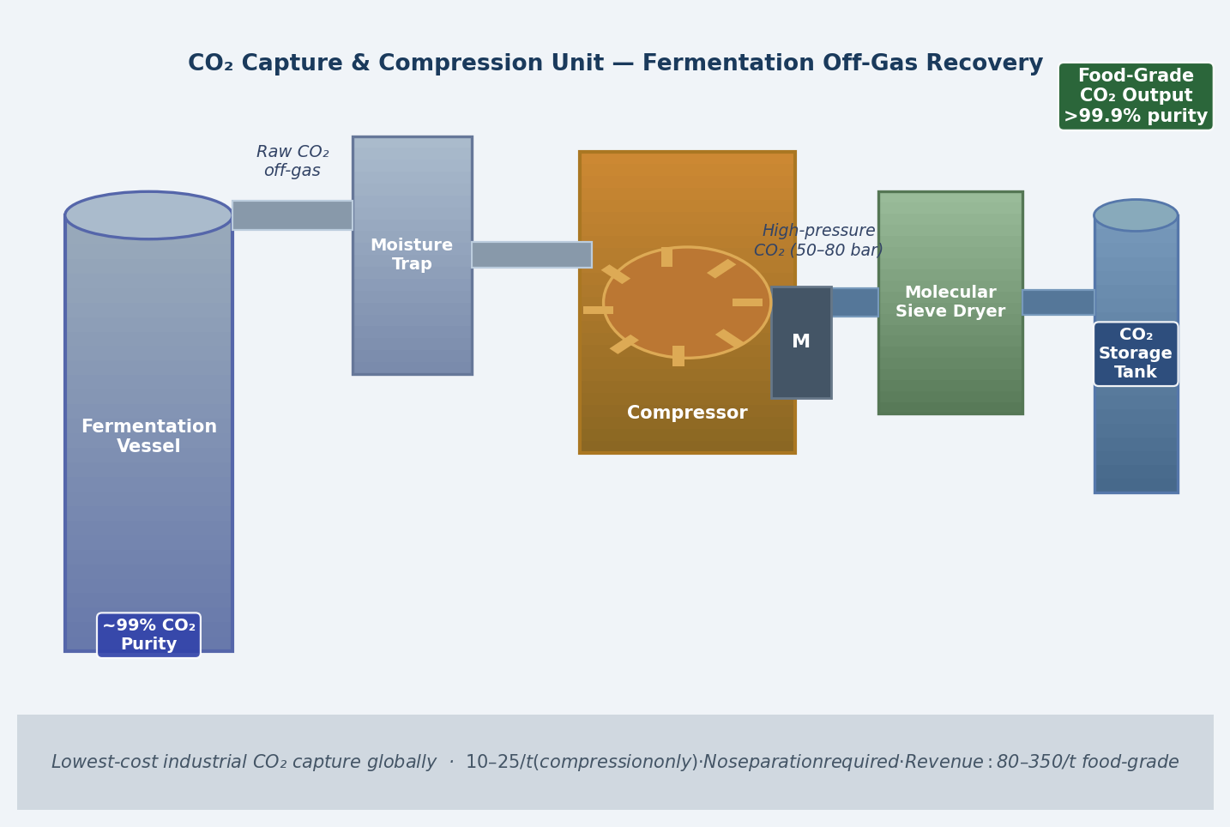
Fig. 2 CO₂ capture and compression unit — fermentation off-gas (~99% purity) moisture-trapped, compressed to 50–80 bar, and dried; food-grade or industrial dispatch at $80–350/t; capital cost $1.5–2.5M per plant; payback 3–6 months
This is the highest-ROI module in the ATRIS system. Fermentation CO2 is the purest industrial CO2 stream available — no separation from combustion gases, no post-combustion capture equipment, no flue gas desulphurisation required. The CO2 exits the fermentation tank at ~99% purity. It requires only compression, drying, and quality verification before use or sale.
Utilisation Route | Market | Value per Tonne CO₂ | Maturity
Food-grade CO2 (beverage carbonation, food preservation) | Domestic food & beverage industry; export | $150–$350/t | Commercial — immediate deployment
Industrial CO2 (welding, fire suppression, chemicals) | Industrial gas market | $80–$150/t | Commercial — immediate deployment
Enhanced oil recovery (EOR) injection | Petrobras and offshore operators | $40–$80/t | Commercial in select geographies
Biogenic carbon storage (BECCS under RenovaBio credits) | Voluntary and compliance carbon markets | $25–$60/t (credit value) | Emerging — regulatory framework developing
Synthetic methanol via CO2 hydrogenation | Green chemicals; aviation fuel | High — dependent on green H2 cost | Early commercial — cost-competitive by 2028–2030

Module 4: Vinasse Biogas Production
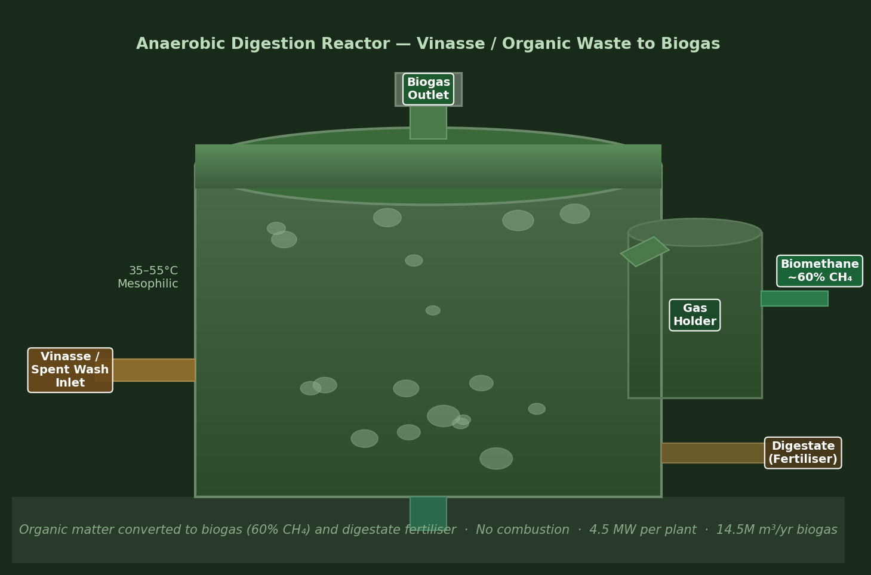
Fig. 3 Anaerobic digestion reactor — vinasse input converted to biogas (60% CH₄) and K-rich digestate at 35–55°C; 4.5 MW per plant; biomethane dispatched to grid injection at approximately R$2.80/m³
Anaerobic digestion of vinasse produces biogas at approximately 60% methane concentration. Each plant producing 120 m³/day of ethanol generates vinasse with pollution potential equivalent to domestic sewage from a city of 300,000. Treating this as an energy resource rather than a waste stream changes the economics of every mill that implements it.
Parameter | Per Plant (120 m³ ethanol/day) | Per Cluster (5 plants avg.) | National (375 plants)
Vinasse volume input | 1,440 m³/day | 7,200 m³/day | 540,000 m³/day
Biogas output (60% CH4) | ~40,000 m³/day | ~200,000 m³/day | ~15B m³/yr
Electrical equivalent | ~4.5 MW | ~22.5 MW | ~1,688 MW national
Bagasse displacement | ~12% of bagasse load | ~12% cluster-wide | Frees 12% of bagasse for 2G ethanol or export
Digestate output (concentrated fertiliser) | High K+ content; ~20–30% of input volume | Cluster fertiliser hub supply | National K-fertiliser supplement

Module 5: Regional Intelligence Layer (AI Optimisation)
The intelligence layer balances resource flows across the cluster in real-time, integrating heat availability (which varies with mill throughput and bagasse moisture content), CO2 production rates (which track fermentation cycles), biogas output (which lags vinasse input by 15–20 days in anaerobic digestion), and market prices for CO2, electricity, and water. The AI layer is not optional — it is what makes the cluster model viable. Without dynamic optimisation across 3–7 mills with different harvest schedules, the fixed infrastructure would operate below design capacity for too much of the season.

5. MASS & ENERGY FLOW MAPPING

The following table maps input streams to output streams at the individual mill level (per 1,000 tonnes of sugarcane processed per day — a mid-scale Brazilian operation). This is the fundamental unit of ATRIS cluster design.

Input (per 1,000 t cane/day) | Current Disposition (baseline) | ATRIS Output (recovered)
280–320 t bagasse | Burned for cogeneration; exhaust heat lost | Existing cogeneration maintained; +15–20 GJ/day additional heat captured for water recovery
~125 m³ ethanol | Primary product — sold | Primary product unchanged; CO2 from fermentation now captured
~1,500 m³ vinasse | Fertigated via open channel; excess lagoon-stored | ~60,000 m³ biogas/day (60% CH4); 900–1,100 m³ recovered water; 350–450 m³ concentrated fertiliser
~125 t fermentation CO₂ | Vented to atmosphere at zero value | ~120 t food/industrial-grade CO₂ captured; revenue $12,000–$42,000/day depending on route
~800–1,000 m³ process wastewater | Effluent treatment; partial discharge | 600–750 m³ recovered for process reuse; 150–200 m³ net discharge reduction
140–180 t cane trash | 50% burned in field; 50% mulch | Gasification option: additional 2–3 MW electric equivalent; or retention as soil carbon (biochar)

6. ECONOMIC MODEL

6.1 Revenue Streams per Cluster (5-mill average, mid-scale)
Revenue Stream | Annual Volume | Price Basis | Annual Revenue
CO2 (food/industrial grade, 70% of capture) | ~150,000 t/yr | $100/t average | $15M/yr
CO2 (BECCS/carbon credits, 30% of capture) | ~65,000 t/yr | $40/t credit | $2.6M/yr
Biogas (grid injection as biomethane) | ~73M m³/yr | R$ 2.80/m³ | ~R$ 204M / $40M/yr
Recovered water (sold to municipalities / industry) | ~1.8M m³/yr | R$ 5.00/m³ | ~R$ 9M / $1.8M/yr
Concentrated fertiliser (K-rich digestate) | ~90,000 t/yr | R$ 800/t | ~R$ 72M / $14.4M/yr
Electricity surplus (from enhanced cogeneration) | ~40 GWh/yr additional | R$ 0.30/kWh | ~R$ 12M / $2.4M/yr
TOTAL CLUSTER ANNUAL REVENUE | — | — | ~$76M/yr

6.2 Capital & Operating Cost Estimate (per cluster)
Component | CAPEX Estimate | OPEX (Annual)
CO2 compression, drying, quality systems (in-plant, 5 mills) | $8–12M | $1.5–2.5M
Anaerobic digestion units (vinasse, 5 mills) | $15–22M | $2–3M
Cluster Processing Hub (CO2 storage, biogas cleaning, fertiliser) | $20–30M | $3–5M
Heat exchanger network + water recovery system | $12–18M | $2–3M
Regional Intelligence Layer (AI, sensors, connectivity) | $3–5M | $0.8–1.2M
TOTAL CAPEX | $58–87M | $9.3–14.7M/yr
Simple payback period | ~14–18 months at full operation | IRR: ~55–75%

6.3 National Scale Economic Potential
Scale | Clusters / Plants | Annual Value Recovery
Phase 1 Pilot (São Paulo belt) | 5 clusters, 25 mills | ~$380M/yr
Phase 2 Expansion (5 states) | 25 clusters, 125 mills | ~$1.9B/yr
Phase 3 National Scale | 50 clusters, 250+ mills | ~$3.8–5.5B/yr
National full deployment (all 375 plants) | 75 clusters | R$ 18–28B/yr ($3.6–5.6B)

7. HIGHEST ROI COMPONENTS: PRIORITY RANKING

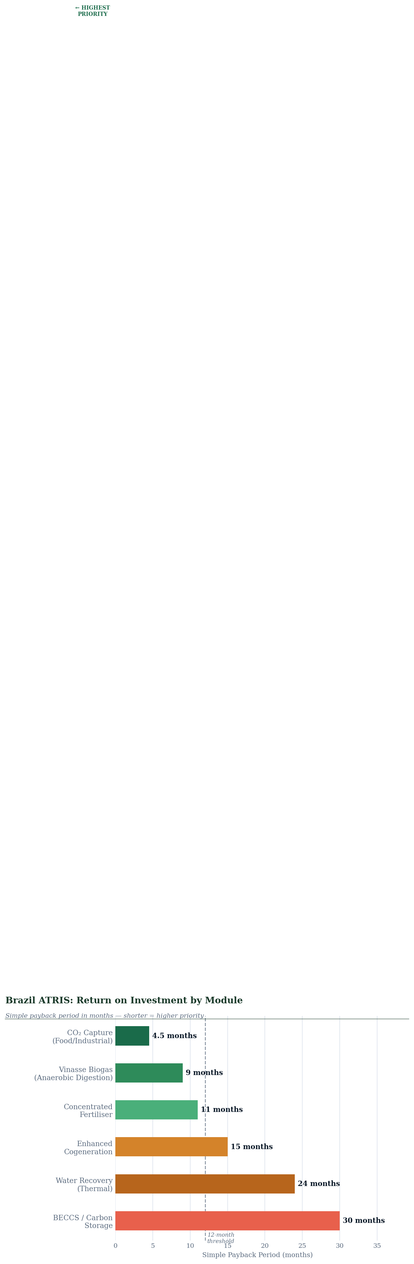
Fig. 4 ATRIS module ROI ranking by payback period — CO₂ capture leads at 4.5 months; vinasse biogas 9 months; concentrated fertiliser 11 months; all three top modules recover capital within 12 months
Not all modules deliver equal return. The following analysis ranks ATRIS modules by ROI, payback period, and implementation complexity, to guide phased deployment decisions.

Rank | Module | CAPEX (per plant) | Annual Revenue | Payback | Complexity
1 | CO2 Capture (food/industrial grade) | $1.5–2.5M | $3–8M | 3–6 months | LOW — compression only; no chemical processing
2 | Vinasse Biogas (anaerobic digestion + grid) | $3–5M | $5–10M | 6–12 months | MEDIUM — proven technology; regulatory pathway exists
3 | Concentrated Fertiliser (K-rich digestate) | $1–2M | $2–4M | 8–14 months | LOW — digestate processing; existing logistics
4 | Enhanced Cogeneration (heat capture) | $2–4M | $2–5M | 12–18 months | MEDIUM — heat exchanger integration
5 | Water Recovery System | $3–5M | $1–3M | 18–30 months | MEDIUM-HIGH — membrane systems; quality management
6 | CO2 BECCS / Carbon Storage | $5–10M | $1–4M (credit value) | 24–36 months | HIGH — regulatory; geological assessment needed

The CO2 capture module is the single most attractive investment in the ATRIS system. It requires no chemical processing, no new feedstock, and minimal energy input — only compression, drying, and quality monitoring. The capital cost is $1.5–2.5M per plant against revenue potential of $3–8M per year. It is the 'lowest-hanging fruit' in the global biogenic carbon economy, and it is currently being vented to atmosphere across all 375 Brazilian ethanol plants simultaneously.

8. COMPARISON WITH GULF SYSTEM (BAHRAIN / SAUDI ARABIA)

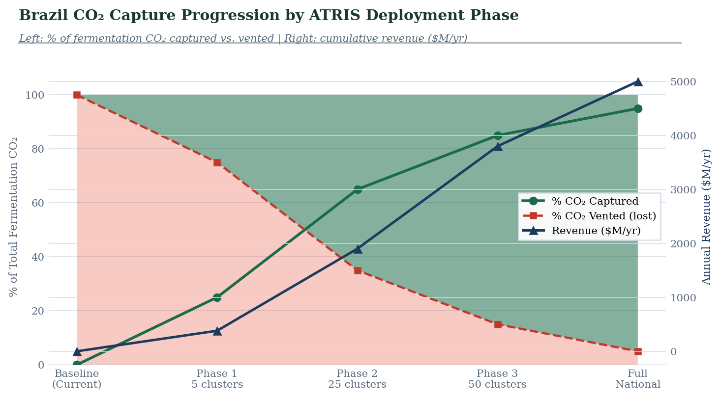
Fig. 5 CO₂ capture progression by deployment phase — percentage captured (green) vs. vented (red) from current baseline (0%) through full national deployment (95%), with annual revenue trajectory on right axis
Dimension | Gulf System (Bahrain / KSA / Kuwait) | Brazil ATRIS System
Core waste stream | Thermal waste heat from petrochemical refineries, aluminium smelters, desalination brine | Biomass waste heat from bagasse combustion; fermentation CO2; vinasse liquid waste
Primary recovery output | Water (industrial and near-potable) | CO2 (primary); biogas (second); water (third)
Architecture | Centralized thermal recovery hub — geographic concentration of heavy industry enables single-site aggregation | Cluster-based — distributed agro-industry across 2,000 km belt requires regional aggregation of 3–7 mills
Energy source for recovery | Industrial waste heat at 150–350°C — high grade | Biomass waste heat at 80–350°C — mixed grade; lower average temperature
Carbon dimension | Carbon-intensive industry; recovery reduces fossil carbon footprint | Carbon-neutral feedstock; biogenic CO2 is net-zero; BECCS creates negative emissions
Market for recovered resources | Water sold to government / industrial users; strategic national need | CO2 sold to global commodity market; biogas grid-injected; fertiliser sold domestically
Regulatory framework | Government-driven; national water security mandate | Market-driven with regulatory incentives (RenovaBio, ProBiogas, voluntary carbon market)
Payback period | 6–19 years (high capex, long-lived infrastructure) | 3–18 months per module (low capex, high-value streams)
Scalability | Limited by geography — industrial sites are fixed | High — 375 plants across 5 major states; cluster model replicable
Core principle | Identical: recover what is already being generated and currently lost | Identical: recover what is already being generated and currently lost

9. SCALABILITY MODEL: CLUSTER-BASED DEPLOYMENT

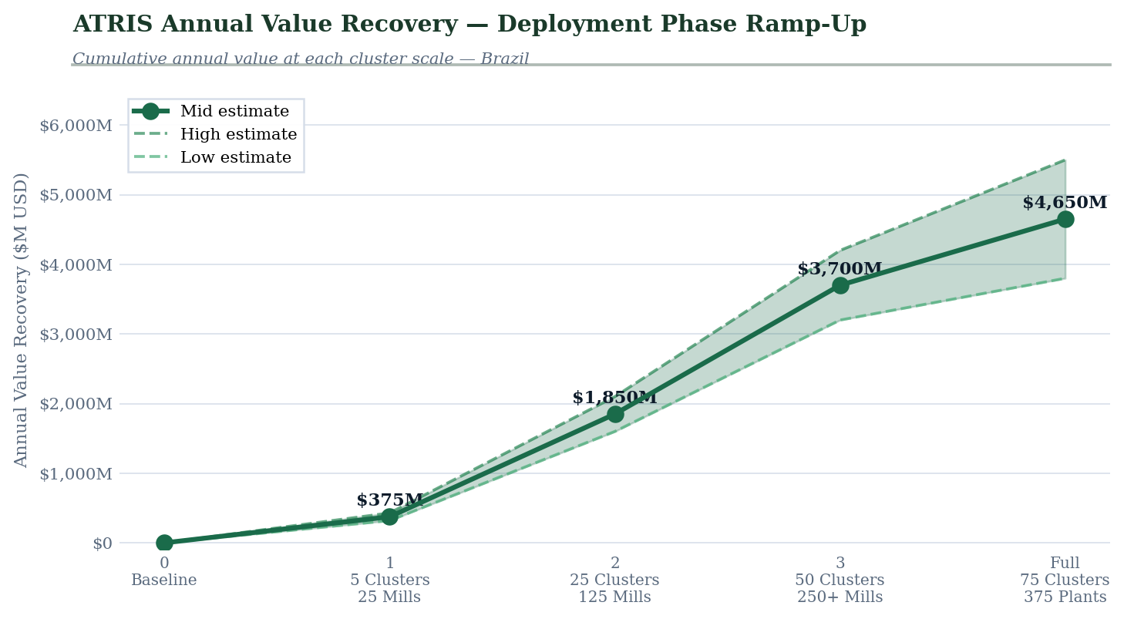
Fig. 6 Annual value recovery by deployment phase — Phase 1 (5 clusters, ~$380M/yr) through full national deployment (75 clusters, R$18–28B/yr); confidence band reflects low and high estimate range
Phase | Region | Scope | Investment | Timeline
Phase 0: Feasibility | 2 candidate mills, São Paulo | Full waste stream characterisation; AI model calibration; cluster partner agreements | $2–5M | Months 1–6
Phase 1: Pilot | 5 clusters, São Paulo belt | CO2 + biogas modules in all 25 mills; shared CPH for CO2 dispatch and fertiliser; RIL deployment | $290–435M | Months 7–24
Phase 2: Expansion | 25 clusters, 5 states | Water recovery module added; full ATRIS stack; carbon credit registration under RenovaBio | $1.45–2.2B | Months 25–48
Phase 3: National | 50 clusters, national | Full national deployment; synthetic fuel pilot (CO2 + green H2); export of ATRIS model to Colombia, Argentina, India | $2.9–4.4B total | Months 49–72

10. RISK REGISTER

Risk | Likelihood | Impact | Mitigation
CO2 market price volatility: food/industrial CO2 market is liquid but price-sensitive | Medium | Medium | Diversify utilisation routes (food + industrial + BECCS credits); fix long-term offtake contracts for 60–70% of volume; keep 30–40% spot
Harvest seasonality: 200–240 day season leaves fixed infrastructure idle for ~125 days | High (inherent) | Medium | Corn ethanol integration in off-season (growing sector in Mato Grosso); design for 55% annual capacity factor in financial model; biogas storage extends production beyond harvest
Anaerobic digestion performance: vinasse composition varies by mill type (annexed vs. autonomous) and feedstock | Medium | Medium | Site-specific digester design informed by Phase 0 characterisation; tubular plug-flow digesters show higher robustness for vinasse variation
Mill consolidation risk: Brazil's sugar-ethanol industry is consolidating; cluster partner mills may be acquired or closed | Medium | High | Design contracts at cluster level, not individual mill; minimum 3-mill threshold for CPH viability; acquisition clauses require incoming owners to honour ATRIS agreements
RenovaBio regulatory change: biofuel policy shifts could affect CO2 credit revenues | Low–Medium | Medium | CO2 food/industrial revenue is independent of RenovaBio; BECCS credits represent <15% of total revenue in base case
Water recovery market: municipalities and industrial buyers may be slow to contract recovered water | Medium | Low | Water recovery module is Phase 2 — by then, 25 clusters operational and proven; price at 30–40% discount to potable water supply cost to ensure uptake

11. GOVERNANCE & INSTITUTIONAL FRAMEWORK

Stakeholder | Role | Engagement Required
MME: Ministry of Mines and Energy | Primary federal sponsor; regulatory framework for biogas grid injection and CO2 utilisation | Policy alignment on ATRIS as a RenovaBio-compatible infrastructure; grid injection regulations for biomethane
MAPA: Ministry of Agriculture | Agricultural byproduct classification; vinasse regulation; fertiliser market oversight | Reclassification of ATRIS outputs (biogas, digestate) as agricultural inputs for preferential regulatory treatment
ANEEL: National Electric Energy Agency | Biogas-to-grid regulatory approval; cogeneration surplus export | Grid injection licensing for cluster-scale biomethane; expedited licensing track for ATRIS clusters
ANP: National Petroleum Agency | Biomethane quality standards; synthetic fuel pathways | Biomethane specification alignment; regulatory pathway for CO2-to-synthetic-fuel production
UNICA: Sugarcane Industry Association | Industry coordination; mill operator engagement; harvest data | Formal partnership for cluster identification, mill introduction, and industry data access
Petrobras | EOR CO2 offtake potential; synthetic fuel co-development | Commercial offtake agreement exploration for captured CO2 in pre-salt EOR operations
Development Banks (BNDES, IFC) | Project finance; green bond issuance | BNDES Fundo Verde alignment; IFC green facility for international capital mobilisation
Sagar-Raja (Private Operator) | 100% CAPEX; cluster design, construction, and operation | BOOT concession structure; 25-year operating license; performance bond

12. RECOMMENDATION & REQUESTED ACTIONS

We respectfully request the Ministry of Mines and Energy's consideration of the following specific actions to initiate the ATRIS programme:

1. | Phase 0 feasibility endorsement | Formal acknowledgement and designation of two candidate mills in the São Paulo belt for Phase 0 waste stream characterisation and AI model calibration
2. | UNICA partnership | Facilitated introduction to UNICA for mill operator engagement, harvest schedule data, and vinasse composition data across participating states
3. | RenovaBio integration | Engagement with ANP for ATRIS CO2 capture to qualify as a carbon intensity reduction measure under RenovaBio, unlocking additional credit revenues for participating mills
4. | BNDES green facility alignment | Introduction to BNDES Fundo Verde for project finance structuring, targeting 40–50% debt financing of cluster CAPEX at green interest rates
5. | Biomethane grid injection framework | Engagement with ANEEL for an expedited licensing track for cluster-scale biomethane injection, consistent with Brazil's ProBiogas programme objectives
6. | International positioning | Consider positioning ATRIS within Brazil's COP30 (Belém, 2025) commitments as a demonstration of national-scale biogenic carbon capture and circular bioeconomy infrastructure

This proposal is presented as an independent research initiative. No public capital expenditure is required at Phase 0. The pilot is designed to demonstrate commercial viability before any commitment to scale, making the financial risk to the Brazilian state effectively zero at entry.

Brazil's agro-industry is not just producing fuel. It is generating CO2, water, energy, and fertiliser — and currently accounting for none of it. ATRIS changes the accounting. The byproducts become the business.

DATA SOURCES & REFERENCES

The following primary sources inform the data presented in this proposal:
- USDA Foreign Agricultural Service: Biofuels Annual — Brazil (Aug 2024): ethanol production forecasts, plant count, bagasse cogeneration share, biodiesel production
- PMC / Environmental Science & Technology: Life Cycle GHG Emissions of Brazilian Sugarcane Ethanol — RenovaBio GREET Model (2023): CI data, bagasse combustion profiles, vinasse transportation data
- Frontiers in Energy Research: Vinasse from Sugarcane Ethanol Production — Better Treatment or Better Utilization? (Apr 2017): vinasse composition, AD biogas yield (4.5 MW/plant, 14.5M m³/yr), methane concentration
- ScienceDirect: Mathematical, Economic and Energetic Appraisal of Biomethane and Biohydrogen from Brazilian Ethanol Plants (2021): national vinasse volume (318,000 m³/day from autonomous plants), bagasse volumes (657,000 t/day)
- PMC: Ethanol Production in Brazil — Bridge Between Science and Industry (2016): vinasse ratio (12 L per L ethanol), 360B L/yr vinasse at 30B L ethanol production
- MDPI Sustainability: Sustainable Valorization of Waste and By-Products from Sugarcane Processing (Sep 2022): bagasse composition (30–34% of cane weight), 2G ethanol status, vinasse valorisation pathways
- ScienceDirect / Negative Emission Strategies — RenovaBio (Aug 2025): CI reduction from BECCS from fermentation (32.8 → 10.4 gCO2e/MJ)
- IEA Bioenergy Task 39: Case Studies of CO2 Utilization in the Production of Ethanol (2024/2025): biogenic CO2 utilisation economics, BECCS/BECCU scenario analysis for Brazilian sugarcane biorefineries
- PMC / Environmental Science & Technology: Cost and Life Cycle Emissions of Ethanol with Oxyfuel Boiler CCS (2023): fermentation CCS cost ($52/tCO2e abated), CI reduction (58% from fermentation capture alone)
- Wikipedia / Ethanol Fuel in Brazil: energy balance (8.3–10.2 output/input), bagasse cogeneration (9% of national electricity, 3 GW in 2007 growing to 12.2 GW by 2014), PROÁLCOOL history
- ScienceDirect: Economic Evaluation of Vinasse vs. Bagasse for Power in Paraná (2017): per-plant mass balance (4,000 t cane/day → 500 m³ ethanol, 720 t bagasse, 4,000 t vinasse), AD feasibility economics
- ACS Sustainable Chemistry & Engineering: Ethanol from Sugarcane — Current State and Strategy (2021): 2G ethanol status (Raízen, GranBio), bagasse hydrolysis glucose/xylose yields
- ScienceDirect: Waste Biogenic Carbon to Alternative Methanol — CO2 Hydrogenation from Ethanol Distilleries (Feb 2025): techno-economic analysis of CO2-to-methanol pathway under Brazilian conditions

Prepared as an Independent Research Study · April 2026
Sagar-Raja · Abu Dhabi Global Market (ADGM), UAE
This study is unsolicited and not submitted on behalf of any government, institution, or commercial party.

